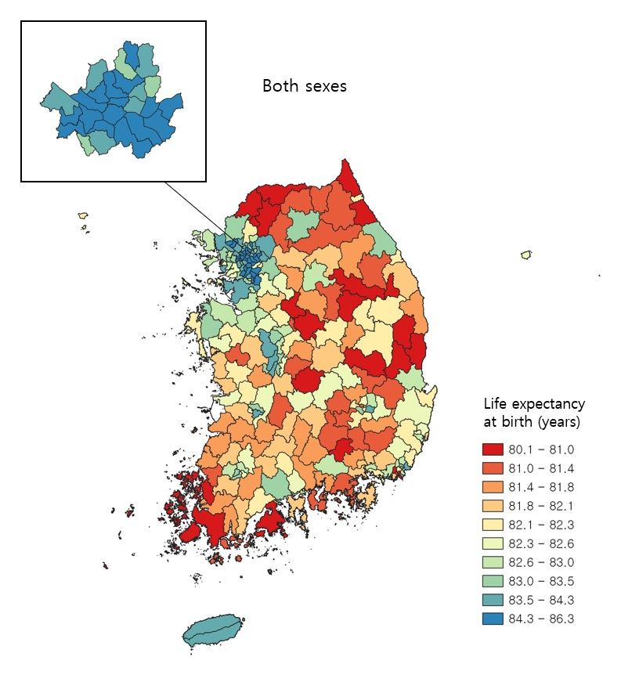
Supplementary Fig. 2. Life expectancy at birth in 250 districts for both sexes combined in Korea, 2017, shown in 10 color groups with ranges for the categories determined by the deciles of life expectancy at birth.

