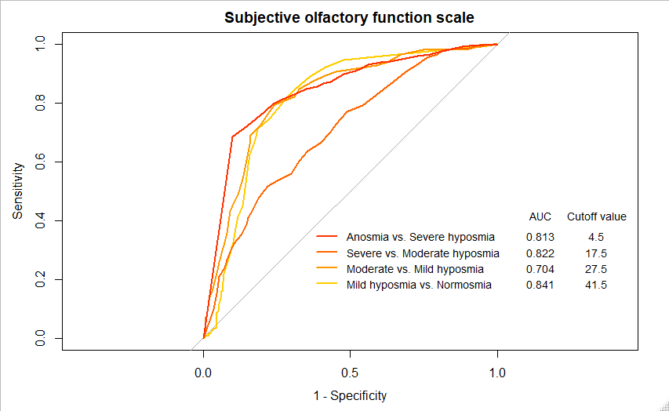
Supplementary Fig. 1. ROC curves among the subclasses are created to identify the cutoff threshold scores for olfactory questionnaire. The self-rating scale for olfactory dysfunction is used as a reference. The predictive ability is calculated based on the AUC, and the cutoff values for each level of olfactory dysfunction are described.
AUC = area under the curve, ROC = receiver operating characteristic.

