Supplementary figure 1. Age distribution of both vaccine groups according to occupation.
- ChAdOx1 vaccine recipients (B) BNT162B2 vaccine recipients

(A)
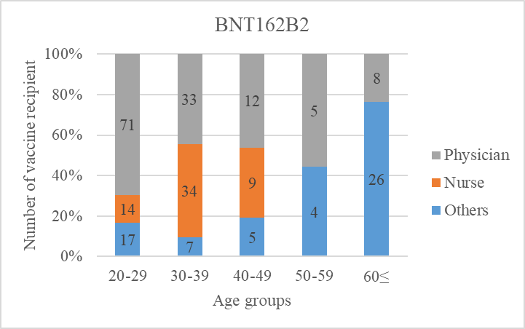

(B)
