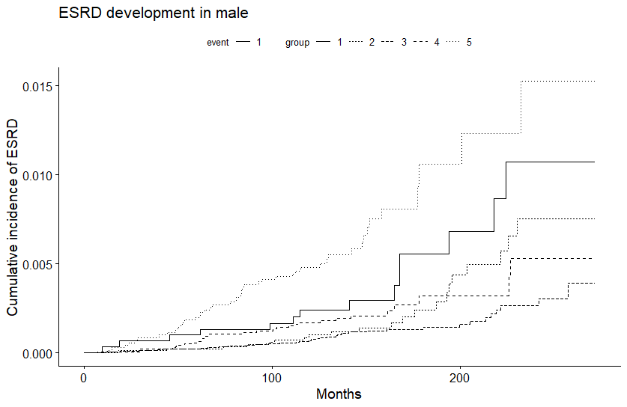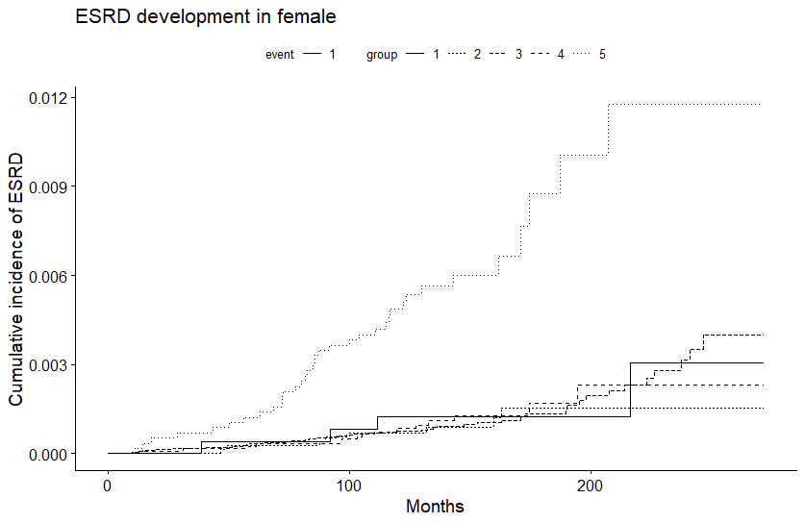 Supplementary Fig. 5. Cumulative incidence curves for ESRD development for serum uric acid quintiles in both sexes. (A) High cumulative incidence was found in the highest and lowest quintiles in males. group 1: < 5.10 mg/dL, group 2: 5.10–5.79 mg/dL, group 3: 5.80–6.39 mg/dL, group 4: 6.40–7.09 mg/dL, group 5: ≥ 7.10 mg/dL, (B) High cumulative incidence was found only in the highest quintile in females. group 1: < 3.60 mg/dL, group 2: 3.60–4.09 mg/dL, group 3: 4.10–4.49 mg/dL, group 4: 4.50–5.09 mg/dL, group 5: ≥ 5.10 mg/dL.
A
B
P value for Gray’s test <0.001
P value for Gray’s test <0.001
ESRD = end-stage renal disease.

