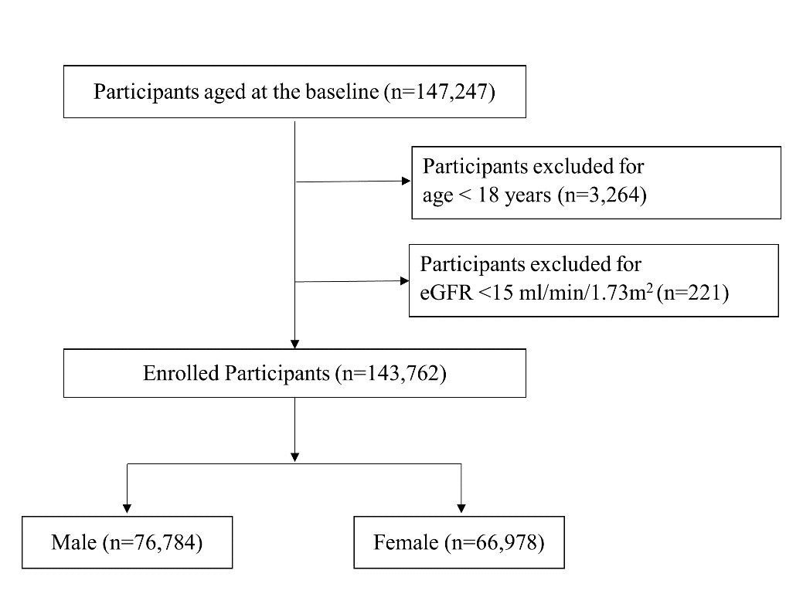
Supplementary Fig. 1. Selection of study participants. eGFR, estimated glomerular filtration rate.

