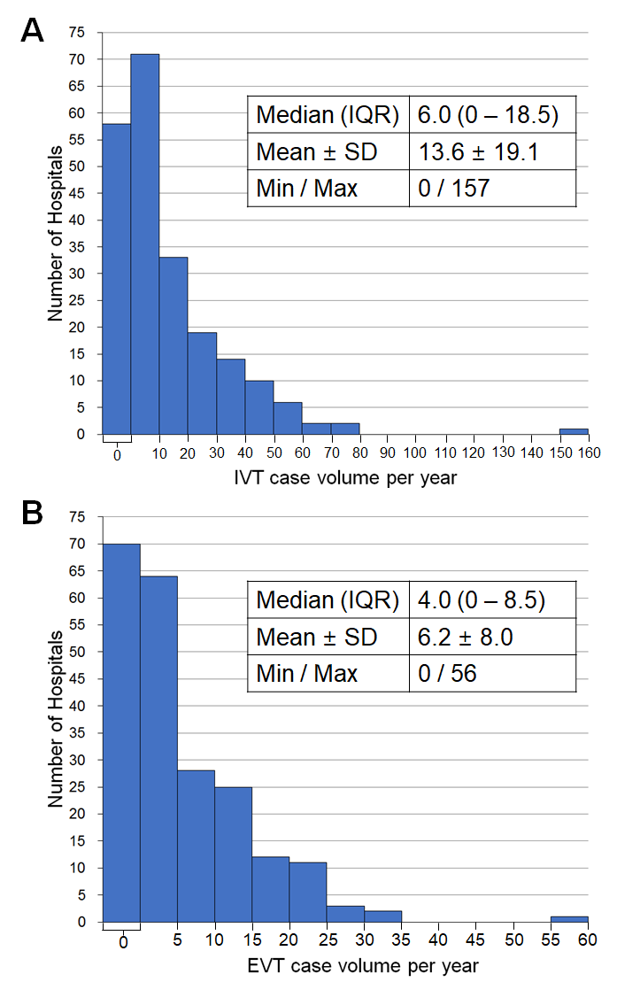
Supplementary Fig. 4. Histogram of hospital case volume for reperfusion therapy. (A) Hospital IVT case volume, and (B) hospital EVT case volume.
IVT = intravenous thrombolysis, EVT = endovascular treatment, IQR = interquartile range, SD = standard deviation.

