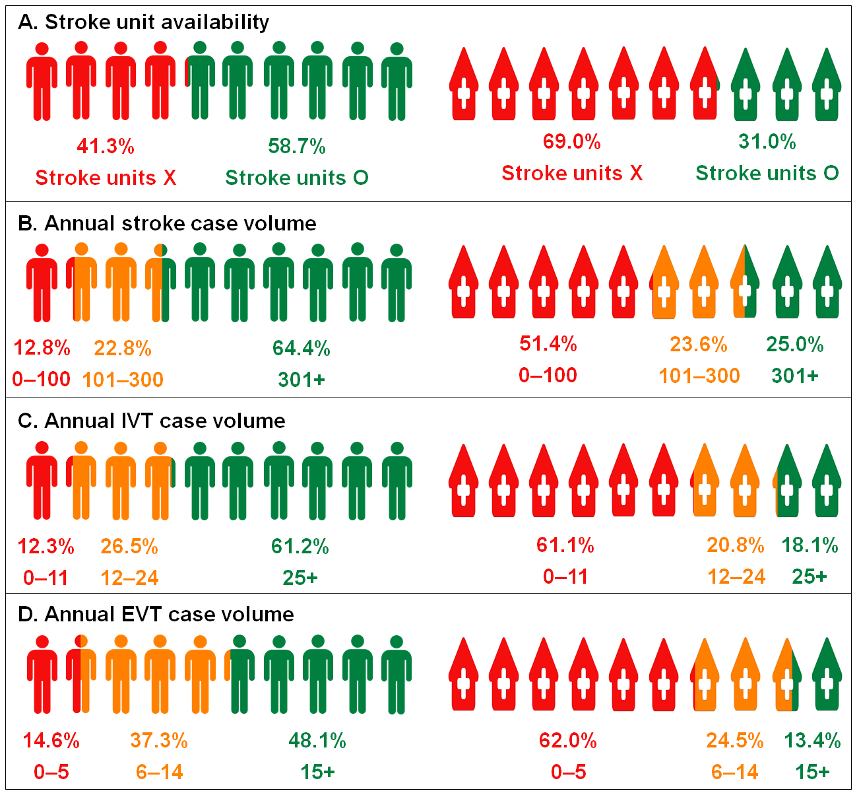
Supplementary Fig. 3. Proportions of acute ischemic stroke patients and acute care hospitals by each subgroup. (A) Stroke unit availability, (B) stroke case volume, (C) IVT case volume, and (D) EVT case volume.
The proportion of acute ischemic stroke patients was schematized on the left half, and the proportion of acute care hospitals on the right half. Of those with acute ischemic stroke, 58.7 percent were admitted to hospitals with stroke units. Only 31.0 percent of acute care hospitals had stroke units. We have defined the criteria for low volume hospitals for each of items including the annual stroke case volume (≤ 300 cases per year for total number of admission for stroke), IVT case volume (≤ 24 cases per year), and EVT case volume (≤ 14 cases per year). The volume cut-off values related to IVT and EVT were based on the eligibility criteria for the comprehensive and thrombectomy-capable stroke center certification program by the Joint Commission.¹
IVT = intravenous thrombolysis, EVT = endovascular treatment.

