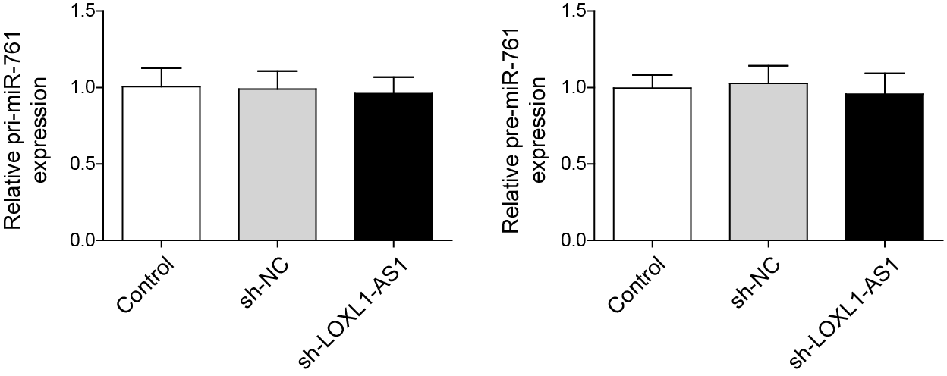
Supplementary Figure 2. Effect of LOXL1-AS1 knockdown on pri-miR-761 and pre-miR-761 levels.
LOXL1-AS1 = lysyl oxidase like 1 antisense RNA 1.

