Supplemental Material 1. Search strategies used
PubMed
“Stroke”[mh] OR “Ischemic stroke”[mh] OR “Embolic stroke”[mh] OR “Cerebral Infarction”[mh] OR “Infarction, middle cerebral artery”[mh] OR “Brain infarction”[mh] OR “Stroke, lacunar”[mh] OR “Thrombotic stroke”[mh] OR Stroke[tiab] OR Cerebral infarction[tiab] OR Brain infarction[tiab] OR Middle cerebral artery infarct*[tiab] OR Middle cerebral artery occlusion[tiab] OR Cerebral infarct*[tiab] OR Brain infarct*[tiab] OR Hemorrhagic strokes[tiab] OR Stroke[tiab] OR Cerebrovascular accident[tiab] OR Cerebrovascular accident, [tiab] OR Apoplexy[tiab] OR Brain vascular accident*[tiab] OR Cryptogenic embolism[tiab] OR Cerebral infarct*[tiab] OR Subcortical infarction[tiab] OR Choroidal artery infarction [tiab] OR MCA infarction[tiab] OR Cerebral artery Infarction[tiab] OR Cerebral artery embol*[tiab] OR Cerebral artery occlusion[tiab] OR Cerebral artery thromb*[tiab] OR Brain venous infarction[tiab] OR Cerebral ischemia reperfusion injury[tiab] OR Brain ischemi* reperfusion injury[tiab] OR Brain ischemia/reperfusion[tiab] OR Cerebral ischemia/reperfusion[tiab] OR Cerebral reperfusion injury[tiab] OR Reperfusion brain injury[tiab] OR Acute cerebrovascular lesion[tiab] OR Acute focal cerebral vasculopathy[tiab] OR Brain vascular accident[tiab] OR Cerebrovascular injury[tiab] OR Cortical infarction[tiab] OR Hemisphere infarct*[tiab] OR Hemispheric infarct*[tiab] OR Brain stem infarction*[tiab] OR Brainstem infarction[tiab] OR Cerebellar infarction[tiab] OR Brain ischemia[tiab] OR Brain ischaemic attack[tiab] OR Brain ischemic attack[tiab]

AND

“Interleukin-1 receptor-Like 1 Protein”[mh] OR SUPPRESSION OF TUMORIGENICITY 2 protein*[tiab] OR Soluble suppression of tumorigenicity-2[tiab] OR sST2[tiab] OR ST2[tiab] OR Interleukin 1 receptor-like 1 protein[tiab] OR IL1RL1 protein*[tiab] OR protein IL1RL1[tiab] OR ST2 protein [tiab] OR ST2S protein*[tiab] OR protein ST2[tiab] OR Stimulation-2 protein[tiab] OR FIT-1 protein[tiab] OR Fos-induced transcript 1 protein[tiab] OR ST2V protein*[tiab] OR ST2L protein*[tiab]

EMBASE
“Cerebral ischemia reperfusion injury”/exp OR “Cerebrovascular accident”/exp OR “Cardioembolic stroke”/exp OR “Brain infarction”/exp OR “Brain stem infarction”/exp OR “Cerebellum infarction”/exp OR “Brain ischemia”/exp OR “Transient ischemic attack”/exp OR “Stroke”:ab,ti OR “Cerebral Infarction”:ab,ti OR “Brain infarction”:ab,ti OR “Middle cerebral artery infarct*”:ab,ti OR “Middle cerebral artery occlusion”:ab,ti OR “Cerebral Infarct*”:ab,ti OR “Brain Infarct*”:ab,ti OR “Hemorrhagic strokes”:ab,ti OR “Stroke”:ab,ti OR “Cerebrovascular accident”:ab,ti OR “Cerebrovascular accident, “:ab,ti OR “Apoplexy”:ab,ti OR “Brain vascular accident*”:ab,ti OR “Cryptogenic embolism”:ab,ti OR “Cerebral infarct*”:ab,ti OR “Subcortical infarction”:ab,ti OR “Choroidal artery infarction “:ab,ti OR “MCA infarction”:ab,ti OR “Cerebral artery infarction”:ab,ti OR “Cerebral artery embol*”:ab,ti OR “Cerebral artery occlusion”:ab,ti OR “Cerebral artery thromb*”:ab,ti OR “Brain venous infarction”:ab,ti OR “Cerebral ischemia reperfusion injury”:ab,ti OR “Brain ischemi* reperfusion injury”:ab,ti OR “Brain ischemia/reperfusion”:ab,ti OR “Cerebral ischemia/reperfusion”:ab,ti OR “Cerebral reperfusion injury”:ab,ti OR “Reperfusion brain injury”:ab,ti OR “Acute cerebrovascular lesion”:ab,ti OR “Acute focal cerebral vasculopathy”:ab,ti OR “Brain vascular accident”:ab,ti OR “Cerebrovascular injury”:ab,ti OR “Cortical infarction”:ab,ti OR “Hemisphere infarct*”:ab,ti OR “Hemispheric infarct*”:ab,ti OR “Brain stem infarction*”:ab,ti OR “Brainstem infarction”:ab,ti OR “Cerebellar infarction”:ab,ti OR “Brain ischemia”:ab,ti OR “Brain ischaemic attack”:ab,ti OR “Brain ischemic attack”:ab,ti

AND

“Interleukin 1 receptor like 1 protein”/exp OR “Suppression of tumorigenicity 2 protein*”:ab,ti OR “Soluble suppression of tumorigenicity-2”:ab,ti OR “sST2”:ab,ti OR “ST2”:ab,ti OR “Interleukin 1 receptor-like 1 protein”:ab,ti OR “IL1RL1 protein*”:ab,ti OR “Protein IL1RL1”:ab,ti OR “ST2 protein “:ab,ti OR “ST2S protein*”:ab,ti OR “Protein ST2”:ab,ti OR “Stimulation-2 protein”:ab,ti OR “FIT-1 protein”:ab,ti OR “Fos-induced transcript 1 protein”:ab,ti OR “ST2V protein*”:ab,ti OR “ST2L protein*”:ab,ti

SCOPUS
TITLE-ABS-KEY (“Stroke” OR “Cerebral infarction” OR “Brain infarction” OR “Middle cerebral artery infarct*” OR “Middle cerebral artery occlusion” OR “Cerebral infarct*” OR “Brain infarct*" OR “Hemorrhagic strokes” OR “Stroke” OR “Cerebrovascular accident” OR “Cerebrovascular accident,” OR “Apoplexy” OR “Brain vascular accident*” OR “Cryptogenic embolism” OR “Cerebral infarct*” OR “Subcortical infarction” OR “Choroidal artery infarction” OR “MCA infarction” OR “Cerebral artery infarction” OR “Cerebral artery embol*” OR “Cerebral artery occlusion” OR “Cerebral artery thromb*” OR “Brain venous infarction” OR “Cerebral ischemia reperfusion injury” OR “Brain ischemi* reperfusion injury” OR “Brain ischemia/reperfusion” OR “Cerebral ischemia/reperfusion” OR “Cerebral reperfusion injury” OR “Reperfusion brain injury” OR “Acute cerebrovascular lesion” OR “Acute focal cerebral vasculopathy” OR “Brain vascular accident” OR “Cerebrovascular injury” OR “Cortical infarction” OR “Hemisphere infarct*” OR “Hemispheric infarct*” OR “Brain stem infarction*” OR “Brainstem infarction” OR “Cerebellar infarction” OR “Brain ischemia” OR “ Brain ischaemic attack” OR “Brain ischemic attack”)

AND

(TITLE-ABS-KEY (“SUPPRESSION OF TUMORIGENICITY 2 protein”) OR TITLE-ABS-KEY (“Soluble suppression of tumorigenicity-2”) OR TITLE-ABS-KEY (“sST2”) OR TITLE-ABS-KEY (“ST2”) OR TITLE-ABS-KEY (“interleukin 1 receptor-like 1 protein”) OR TITLE-ABS-KEY (“IL1RL1 protein”) OR TITLE-ABS-KEY (“protein IL1RL1”) OR TITLE-ABS-KEY (“ST2 protein”) OR TITLE-ABS-KEY (“ST2S protein”) OR TITLE-ABS-KEY (“protein ST2”) OR TITLE-ABS-KEY (“Stimulation-2 protein”) OR TITLE-ABS-KEY (“FIT-1 protein”) OR TITLE-ABS-KEY (“Fos-induced transcript 1 protein”) OR TITLE-ABS-KEY (“ST2V protein" ) OR TITLE-ABS-KEY (“ST2L protein”))

Web of Science
ALL=(“Suppression of tumorigenicity 2 protein” OR “Soluble suppression of tumorigenicity-2” OR “sST2” OR “ST2” OR “Interleukin 1 receptor-like 1 protein” OR “IL1RL1 protein” OR “Protein IL1RL1” OR “ST2 protein” OR “ST2S protein” OR “protein ST2” OR “Stimulation-2 protein” OR “FIT-1 protein” OR “Fos-induced transcript 1 protein”)

AND

ALL=(“Stroke” OR “Cerebral infarction” OR “Brain infarction” OR “Middle cerebral artery infarct*” OR “Middle cerebral artery occlusion” OR “Cerebral infarct*” OR “Brain infarct*” OR “Hemorrhagic strokes” OR “Stroke” OR “Cerebrovascular accident” OR “Cerebrovascular accident, “ OR “Apoplexy” OR “ Brain vascular accident*” OR “Cryptogenic embolism” OR “Cerebral infarct*” OR “Subcortical infarction” OR “Choroidal artery infarction ” OR “MCA infarction” OR “Cerebral artery infarction” OR “Cerebral artery embol*” OR “Cerebral artery occlusion” OR “Cerebral artery thromb*” OR “Brain venous infarction” OR “Cerebral ischemia reperfusion injury” OR “Brain ischemi* reperfusion injury” OR “Brain ischemia/reperfusion” OR “Cerebral ischemia/reperfusion” OR “Cerebral reperfusion injury” OR “Reperfusion brain injury” OR “Acute cerebrovascular lesion” OR “Acute focal cerebral vasculopathy” OR “Brain vascular accident” OR “Cerebrovascular injury” OR “Cortical infarction” OR “Hemisphere infarct*” OR “Hemispheric infarct*” OR “Brain stem infarction*” OR “Brainstem infarction” OR “Cerebellar infarction” OR “Brain ischemia” OR “Brain ischaemic attack” OR “Brain ischemic attack”)

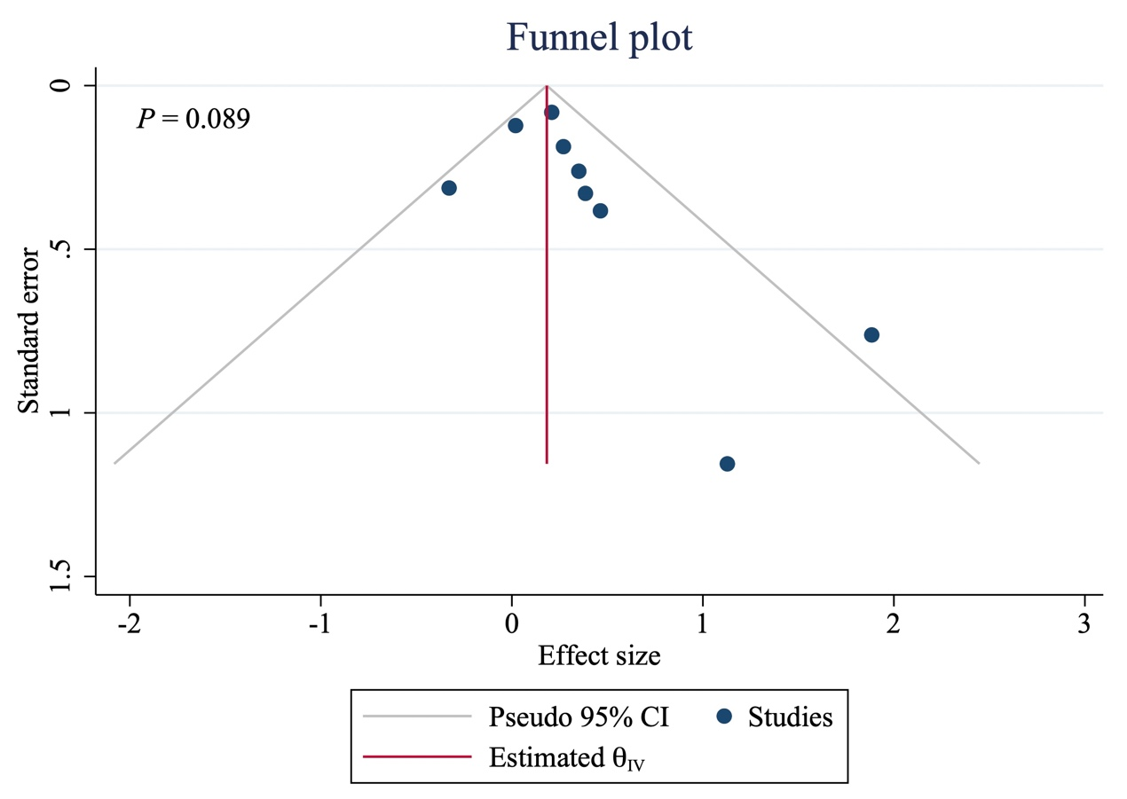
Supplemental Data Figure S1. Publication bias of the included studies on the value of serum sST-2 levels in the prediction of stroke. Estimated 𝜃_{IV} indicates the pooled estimated effect size determined using the inverse variance-weighted average model.
Abbreviation: CI, confidence interval.

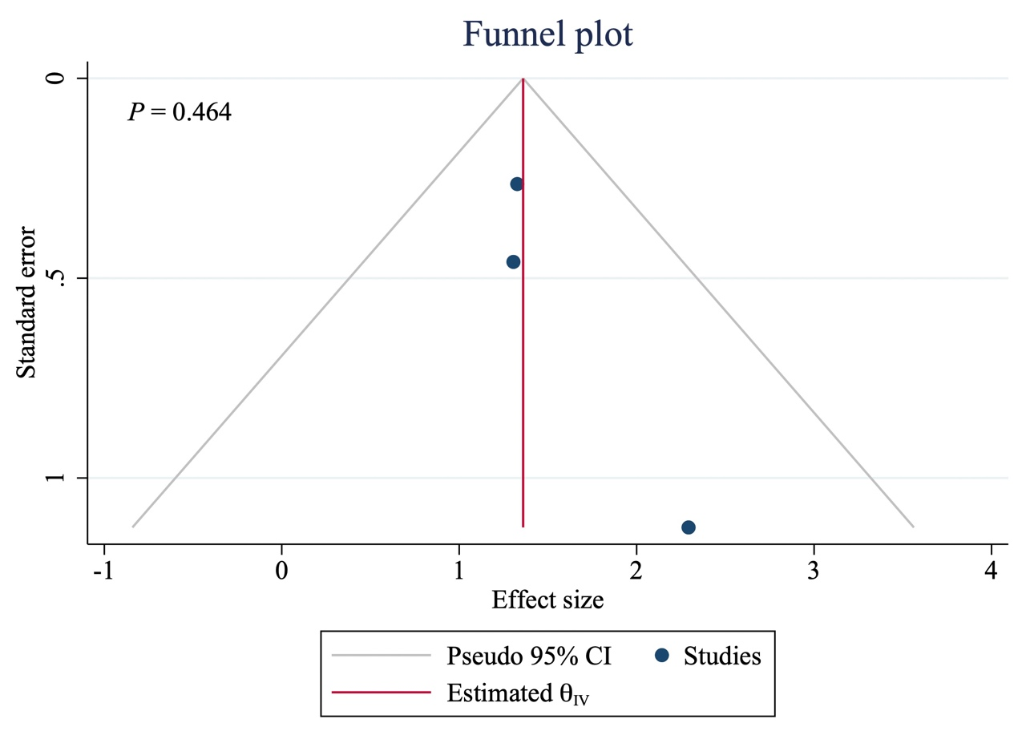

Supplemental Data Figure S2. Publication bias of the included studies on the value of serum sST-2 in the prognosis of post-stroke outcomes. Estimated 𝜃_{IV} indicates the pooled estimated effect size determined using the inverse variance-weighted average model.
Abbreviation: CI, confidence interval.

